Ideas for Transformation in Creative Writing:

- What animal do you feel an affinity to?

- Why is that the case?

- Imagine transforming into that animal. How do you feel?

- How do your friends and family feel about you now that you are an animal?

- Write a short folktale about your adventures as that animal.

- Did you enjoy being transformed, or has it made you appreciate your human life?

Further Reading:
The beginning of Gone to Earth – by Mary Webb

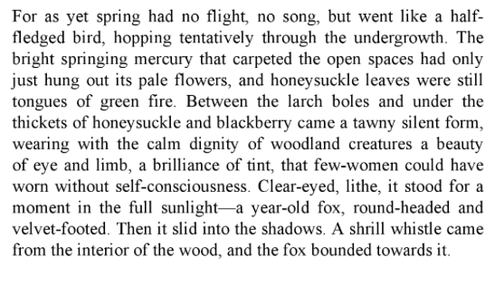
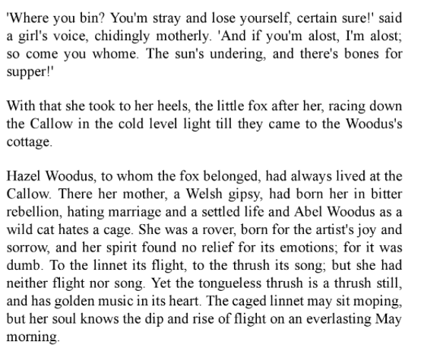

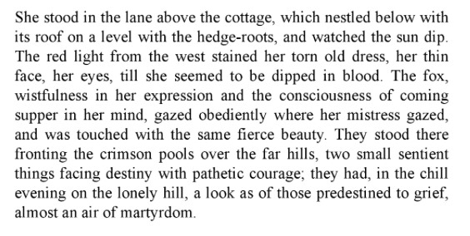

Hazel Woodus and the Death Pack from Gone to Earth

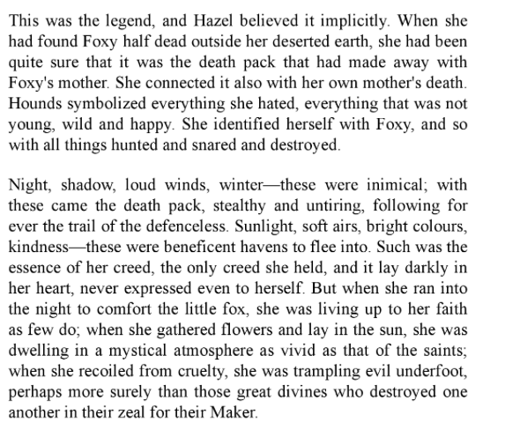

The Wild Hunt -

Fascinating information about this widespread legend of European Folklore and Wild Eadric’s association with it can be found on the following websites:

https://fellowshipandfairydust.com/2019/07/01/the-wild-hunt/

https://folklorethursday.com/legends/british-legends-wild-edric-the-wild-hunt-and-the-bride-from-the-otherworld/

https://en.wikipedia.org/wiki/Wild_Hunt

https://en.wikipedia.org/wiki/Eadric_the_Wild

